Final Project
Katie Northrup
2025-12-02
# 1. DATA LOADING AND PREPARATION
setwd("C:/Users/katie/Downloads")
df <- read_csv("Sleep_health_and_lifestyle_dataset.csv")
## Rows: 374 Columns: 13
## ── Column specification ────────────────────────────────────────────────────────
## Delimiter: ","
## chr (5): Gender, Occupation, BMI Category, Blood Pressure, Sleep Disorder
## dbl (8): Person ID, Age, Sleep Duration, Quality of Sleep, Physical Activity...
##
## ℹ Use `spec()` to retrieve the full column specification for this data.
## ℹ Specify the column types or set `show_col_types = FALSE` to quiet this message.
df <- df %>%
rename(
SleepDuration = `Sleep Duration`,
SleepQuality = `Quality of Sleep`,
Activity = `Physical Activity Level`,
Stress = `Stress Level`,
BMI = `BMI Category`,
SleepDisorder = `Sleep Disorder`,
Steps = `Daily Steps`,
HeartRate = `Heart Rate`
) %>%
mutate(
Gender = factor(Gender),
Occupation = factor(Occupation),
BMI = factor(BMI),
SleepDisorder = factor(SleepDisorder),
SleepQuality = as.numeric(SleepQuality),
SleepDuration = as.numeric(SleepDuration),
Stress = as.numeric(Stress),
Activity = as.numeric(Activity),
Steps = as.numeric(Steps),
HeartRate = as.numeric(HeartRate)
) %>%
drop_na()
dim(df) # Dataset dimensions
## [1] 374 13
# 2. EXPLORATORY DATA ANALYSIS
ggplot(df, aes(Stress, SleepQuality)) +
geom_point(alpha=0.5) +
geom_smooth(method="lm") +
theme_minimal() +
labs(title="Relationship Between Stress and Sleep Quality")
## `geom_smooth()` using formula = 'y ~ x'
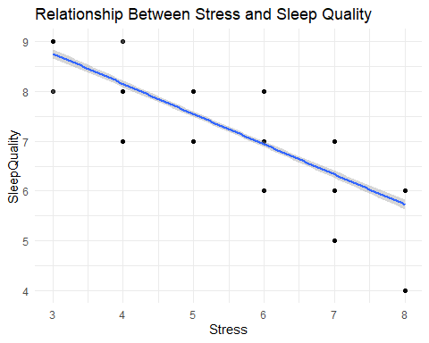
ggplot(df, aes(Activity, SleepQuality)) +
geom_point(alpha=0.5) +
geom_smooth(method="lm") +
theme_minimal() +
labs(title="Effect of Physical Activity on Sleep Quality")
## `geom_smooth()` using formula = 'y ~ x'
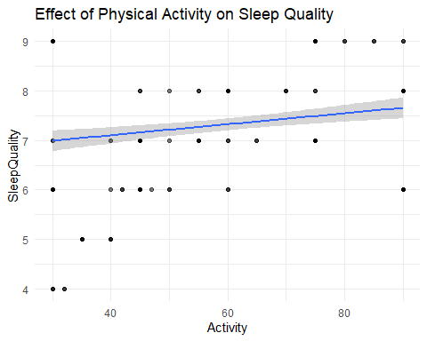
ggplot(df, aes(SleepDisorder)) +
geom_bar() +
theme_minimal() +
labs(title="Distribution of Sleep Disorder Categories")
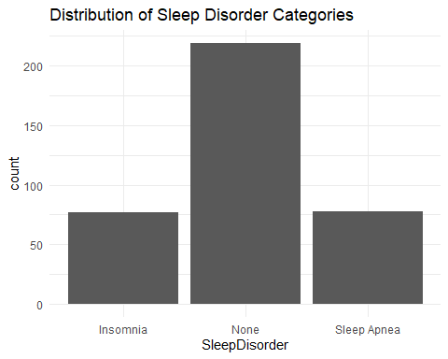
ggplot(df, aes(BMI, SleepQuality, fill = BMI)) +
geom_boxplot() +
theme_minimal() +
labs(title="Sleep Quality by BMI Category") +
theme(legend.position = "none")
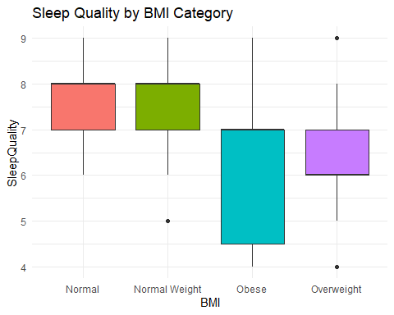
numeric_vars <- df %>%
dplyr::select(SleepQuality, SleepDuration, Stress, Activity, Steps, HeartRate, Age)
GGally::ggpairs(numeric_vars)
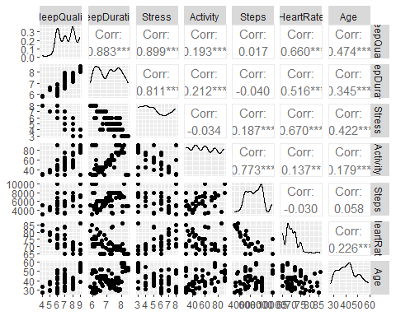
# 3. LINEAR MODEL FOR SLEEP QUALITY
lm1 <- lm(SleepQuality ~ Stress + Activity + Steps + HeartRate + Age + Gender + BMI, data = df)
summary(lm1)
##
## Call:
## lm(formula = SleepQuality ~ Stress + Activity + Steps + HeartRate +
## Age + Gender + BMI, data = df)
##
## Residuals:
## Min 1Q Median 3Q Max
## -0.92066 -0.15354 -0.02144 0.15308 1.19654
##
## Coefficients:
## Estimate Std. Error t value Pr(>|t|)
## (Intercept) 6.804e+00 6.123e-01 11.113 < 2e-16 ***
## Stress -4.955e-01 2.149e-02 -23.057 < 2e-16 ***
## Activity 4.021e-03 1.698e-03 2.369 0.0184 *
## Steps 4.484e-05 2.215e-05 2.025 0.0436 *
## HeartRate 6.833e-03 9.503e-03 0.719 0.4726
## Age 5.699e-02 2.819e-03 20.215 < 2e-16 ***
## GenderMale 2.898e-01 4.350e-02 6.662 1.00e-10 ***
## BMINormal Weight -1.209e-01 7.154e-02 -1.691 0.0918 .
## BMIObese -9.538e-01 1.605e-01 -5.942 6.58e-09 ***
## BMIOverweight -9.212e-01 4.567e-02 -20.172 < 2e-16 ***
## ---
## Signif. codes: 0 '***' 0.001 '**' 0.01 '*' 0.05 '.' 0.1 ' ' 1
##
## Residual standard error: 0.2946 on 364 degrees of freedom
## Multiple R-squared: 0.9409, Adjusted R-squared: 0.9394
## F-statistic: 643.9 on 9 and 364 DF, p-value: < 2.2e-16
car::vif(lm1)
## GVIF Df GVIF^(1/(2*Df))
## Stress 6.251878 1 2.500376
## Activity 5.375285 1 2.318466
## Steps 5.519396 1 2.349339
## HeartRate 6.639903 1 2.576801
## Age 2.570235 1 1.603195
## Gender 2.039110 1 1.427974
## BMI 5.886067 3 1.343706
lm2 <- lm(SleepQuality ~ Stress + Age + Gender + BMI, data = df)
summary(lm2)
##
## Call:
## lm(formula = SleepQuality ~ Stress + Age + Gender + BMI, data = df)
##
## Residuals:
## Min 1Q Median 3Q Max
## -1.07559 -0.22695 0.05633 0.18723 1.13882
##
## Coefficients:
## Estimate Std. Error t value Pr(>|t|)
## (Intercept) 7.465663 0.167323 44.618 < 2e-16 ***
## Stress -0.469559 0.012644 -37.136 < 2e-16 ***
## Age 0.062179 0.003067 20.275 < 2e-16 ***
## GenderMale 0.314234 0.044940 6.992 1.29e-11 ***
## BMINormal Weight -0.091085 0.076848 -1.185 0.237
## BMIObese -1.034783 0.106724 -9.696 < 2e-16 ***
## BMIOverweight -0.943185 0.049237 -19.156 < 2e-16 ***
## ---
## Signif. codes: 0 '***' 0.001 '**' 0.01 '*' 0.05 '.' 0.1 ' ' 1
##
## Residual standard error: 0.3277 on 367 degrees of freedom
## Multiple R-squared: 0.9263, Adjusted R-squared: 0.925
## F-statistic: 768.2 on 6 and 367 DF, p-value: < 2.2e-16
anova(lm2, lm1)
## Analysis of Variance Table
##
## Model 1: SleepQuality ~ Stress + Age + Gender + BMI
## Model 2: SleepQuality ~ Stress + Activity + Steps + HeartRate + Age +
## Gender + BMI
## Res.Df RSS Df Sum of Sq F Pr(>F)
## 1 367 39.411
## 2 364 31.585 3 7.8266 30.066 < 2.2e-16 ***
## ---
## Signif. codes: 0 '***' 0.001 '**' 0.01 '*' 0.05 '.' 0.1 ' ' 1
data.frame(Model = c("Full", "Simplified"), AIC = c(AIC(lm1), AIC(lm2)))
## Model AIC
## 1 Full 158.9950
## 2 Simplified 235.7911
par(mfrow=c(2,2))
plot(lm1)
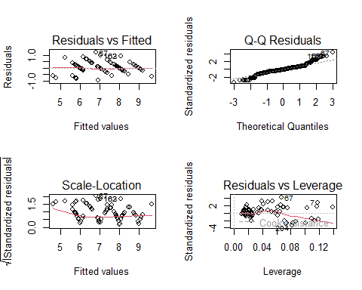
par(mfrow=c(1,1))
shapiro.test(residuals(lm1))
##
## Shapiro-Wilk normality test
##
## data: residuals(lm1)
## W = 0.95131, p-value = 9.03e-10
# 4. LOGISTIC REGRESSION FOR SLEEP DISORDERS
df <- df %>%
mutate(DisorderBinary = ifelse(SleepDisorder == "None", 0, 1))
# Fix separation by combining Overweight and Obese categories
df <- df %>%
mutate(BMI_fixed = case_when(
BMI %in% c("Normal", "Normal Weight") ~ "Normal",
BMI %in% c("Overweight", "Obese") ~ "Overweight/Obese"
),
BMI_fixed = factor(BMI_fixed))
table(df$BMI_fixed, df$DisorderBinary)
##
## 0 1
## Normal 200 16
## Overweight/Obese 19 139
# Logistic regression
logit1_fixed <- glm(DisorderBinary ~ Stress + Activity + Age + Gender + BMI_fixed,
family = binomial, data = df)
summary(logit1_fixed)
##
## Call:
## glm(formula = DisorderBinary ~ Stress + Activity + Age + Gender +
## BMI_fixed, family = binomial, data = df)
##
## Coefficients:
## Estimate Std. Error z value Pr(>|z|)
## (Intercept) -6.715227 1.883807 -3.565 0.000364 ***
## Stress 0.438537 0.159790 2.744 0.006061 **
## Activity 0.004764 0.010215 0.466 0.640949
## Age 0.054647 0.031780 1.720 0.085512 .
## GenderMale -0.798332 0.498495 -1.601 0.109269
## BMI_fixedOverweight/Obese 3.831312 0.410223 9.340 < 2e-16 ***
## ---
## Signif. codes: 0 '***' 0.001 '**' 0.01 '*' 0.05 '.' 0.1 ' ' 1
##
## (Dispersion parameter for binomial family taken to be 1)
##
## Null deviance: 507.47 on 373 degrees of freedom
## Residual deviance: 219.43 on 368 degrees of freedom
## AIC: 231.43
##
## Number of Fisher Scoring iterations: 6
logit2_fixed <- glm(DisorderBinary ~ Stress + Age + Gender + BMI_fixed,
family = binomial, data = df)
summary(logit2_fixed)
##
## Call:
## glm(formula = DisorderBinary ~ Stress + Age + Gender + BMI_fixed,
## family = binomial, data = df)
##
## Coefficients:
## Estimate Std. Error z value Pr(>|z|)
## (Intercept) -6.51306 1.81790 -3.583 0.00034 ***
## Stress 0.42149 0.15031 2.804 0.00504 **
## Age 0.05739 0.03112 1.844 0.06516 .
## GenderMale -0.73541 0.47803 -1.538 0.12395
## BMI_fixedOverweight/Obese 3.82827 0.40794 9.384 < 2e-16 ***
## ---
## Signif. codes: 0 '***' 0.001 '**' 0.01 '*' 0.05 '.' 0.1 ' ' 1
##
## (Dispersion parameter for binomial family taken to be 1)
##
## Null deviance: 507.47 on 373 degrees of freedom
## Residual deviance: 219.65 on 369 degrees of freedom
## AIC: 229.65
##
## Number of Fisher Scoring iterations: 5
anova(logit2_fixed, logit1_fixed, test = "Chisq")
## Analysis of Deviance Table
##
## Model 1: DisorderBinary ~ Stress + Age + Gender + BMI_fixed
## Model 2: DisorderBinary ~ Stress + Activity + Age + Gender + BMI_fixed
## Resid. Df Resid. Dev Df Deviance Pr(>Chi)
## 1 369 219.65
## 2 368 219.43 1 0.22127 0.6381
data.frame(Model = c("With Activity", "Without Activity"),
AIC = c(AIC(logit1_fixed), AIC(logit2_fixed)))
## Model AIC
## 1 With Activity 231.4275
## 2 Without Activity 229.6487
# Choose final logistic model
logit_final <- logit2_fixed
exp(cbind(OR = coef(logit_final), confint(logit_final))) # Odds ratios with CI
## Waiting for profiling to be done...
## OR 2.5 % 97.5 %
## (Intercept) 0.001483928 3.676341e-05 0.04779316
## Stress 1.524234316 1.150529e+00 2.07738157
## Age 1.059071887 9.962393e-01 1.12648249
## GenderMale 0.479307599 1.856701e-01 1.22407635
## BMI_fixedOverweight/Obese 45.982911450 2.141678e+01 106.91074034
pred_logit <- ifelse(predict(logit_final, type="response") > 0.5, 1, 0)
conf_matrix <- table(Predicted = pred_logit, Actual = df$DisorderBinary)
accuracy <- sum(diag(conf_matrix)) / sum(conf_matrix)
sensitivity <- conf_matrix[2,2] / sum(conf_matrix[,2])
specificity <- conf_matrix[1,1] / sum(conf_matrix[,1])
conf_matrix
## Actual
## Predicted 0 1
## 0 200 16
## 1 19 139
data.frame(Accuracy = accuracy, Sensitivity = sensitivity, Specificity = specificity)
## Accuracy Sensitivity Specificity
## 1 0.9064171 0.8967742 0.913242
# 5. EFFECT PLOTS
plot(effects::Effect("Stress", lm1),
main = "Effect of Stress on Sleep Quality (Linear Model)")
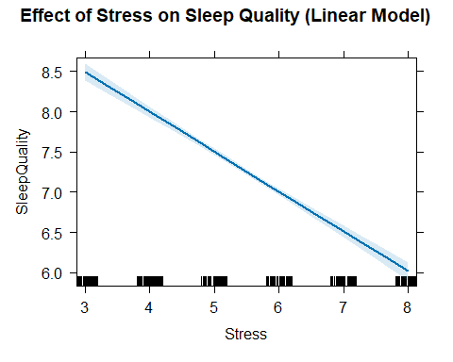
plot(effects::Effect("Stress", logit_final),
main = "Effect of Stress on Probability of Sleep Disorder",
ylab = "Probability", xlab = "Stress Level")
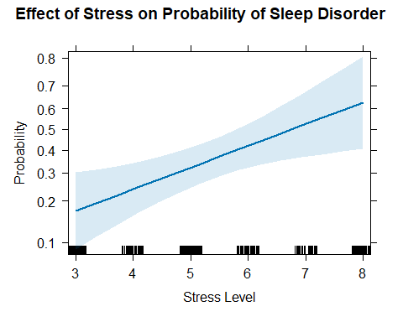
# 6. CLEAN TABLES FOR REPORT
lm1_clean <- broom::tidy(lm1, conf.int = TRUE) %>%
dplyr::select(term, estimate, std.error, conf.low, conf.high, p.value) %>%
mutate(across(where(is.numeric), round, 3))
## Warning: There was 1 warning in `mutate()`.
## ℹ In argument: `across(where(is.numeric), round, 3)`.
## Caused by warning:
## ! The `...` argument of `across()` is deprecated as of dplyr 1.1.0.
## Supply arguments directly to `.fns` through an anonymous function instead.
##
## # Previously
## across(a:b, mean, na.rm = TRUE)
##
## # Now
## across(a:b, \(x) mean(x, na.rm = TRUE))
lm1_clean
## # A tibble: 10 × 6
## term estimate std.error conf.low conf.high p.value
## <chr> <dbl> <dbl> <dbl> <dbl> <dbl>
## 1 (Intercept) 6.80 0.612 5.6 8.01 0
## 2 Stress -0.496 0.021 -0.538 -0.453 0
## 3 Activity 0.004 0.002 0.001 0.007 0.018
## 4 Steps 0 0 0 0 0.044
## 5 HeartRate 0.007 0.01 -0.012 0.026 0.473
## 6 Age 0.057 0.003 0.051 0.063 0
## 7 GenderMale 0.29 0.044 0.204 0.375 0
## 8 BMINormal Weight -0.121 0.072 -0.262 0.02 0.092
## 9 BMIObese -0.954 0.161 -1.27 -0.638 0
## 10 BMIOverweight -0.921 0.046 -1.01 -0.831 0
logit_clean <- broom::tidy(logit_final, conf.int = TRUE, exponentiate = TRUE) %>%
dplyr::select(term, odds_ratio = estimate, conf.low, conf.high, p.value) %>%
mutate(across(where(is.numeric), round, 3))
logit_clean
## # A tibble: 5 × 5
## term odds_ratio conf.low conf.high p.value
## <chr> <dbl> <dbl> <dbl> <dbl>
## 1 (Intercept) 0.001 0 0.048 0
## 2 Stress 1.52 1.15 2.08 0.005
## 3 Age 1.06 0.996 1.13 0.065
## 4 GenderMale 0.479 0.186 1.22 0.124
## 5 BMI_fixedOverweight/Obese 46.0 21.4 107. 0
performance_summary <- data.frame(
Model = c("Linear (Sleep Quality)", "Logistic (Sleep Disorder)"),
R2_Deviance_Explained = c(
round(summary(lm1)$r.squared, 3),
round(1 - (logit_final$deviance/logit_final$null.deviance), 3)
),
AIC = c(round(AIC(lm1), 1), round(AIC(logit_final), 1)),
Accuracy_Classification = c(NA, round(accuracy, 3))
)
performance_summary
## Model R2_Deviance_Explained AIC Accuracy_Classification
## 1 Linear (Sleep Quality) 0.941 159.0 NA
## 2 Logistic (Sleep Disorder) 0.567 229.6 0.906

